Safety of mRNA COVID-19 Vaccines during Pregnancy
Executive Summary¹⁻²
Two rigorous pharmacovigilance studies substantiate the safety of mRNA COVID-19 vaccines (BNT162b2 and mRNA-1273) administered during pregnancy. The primary investigation systematically analyzed 4,869 pregnancy-associated reports submitted to the Vaccine Adverse Event Reporting System (VAERS)¹ from December 2020 to April 2022. This cohort revealed that 94% of events involved mRNA vaccines, with 80.43% classified as nonserious adverse events following immunization. Prominent systemic reactions included headache (2.21%), fatigue (2.16%), and pyrexia (2.00%), while key obstetric outcomes comprised spontaneous abortion (3.49%), vaginal hemorrhage (1.05%), and 1,126 instances of normal pregnancy progression. No novel safety signals beyond established reactogenicity profiles were identified.
Complementarily, a prospective 1:2 matched cohort study² evaluated reactogenicity in 83 pregnant women (median gestation 29 weeks) versus 166 nonpregnant controls, demonstrating statistically equivalent overall reaction rates (18.1% vs 16.9%; P=0.72), albeit with modestly elevated fever (4.8% vs 0.6%; P=0.04) among pregnant participants. These convergent findings affirm vaccination's favorable risk-benefit profile despite gestational COVID-19 morbidity risks (ICU admission OR 1.9).
Introduction¹⁻²
The deployment of mRNA COVID-19 vaccines represented a breakthrough in pandemic mitigation, yet pregnant individuals—excluded from foundational phase 3 trials—required dedicated postauthorization safety assessment. Emergency Use Authorizations issued in December 2020 facilitated empirical administration notwithstanding initial gaps in gestation-specific data. Pregnancy physiologically exacerbates SARS-CoV-2 severity, conferring elevated hazards of maternal mortality (22-fold increase), preeclampsia (OR 1.3), preterm birth (OR 1.6), and stillbirth (HR 2.1 versus unexposed contemporaneous controls). The lead VAERS pharmacovigilance analysis captured 4,869 deduplicated pregnancy reports amid an estimated 5 million antenatal doses administered, wherein mRNA platforms predominated (mRNA-1273 53.34%; BNT162b2 40.68%). This was orthogonally complemented by a single-center prospective cohort enrolling 83 pregnant women (mean age 32.4 years) propensity-matched to 166 nonpregnant reproductive-aged controls for reactogenicity profiling via structured surveys. Methodologic synergy between passive large-scale surveillance and active elicitation mitigates respective biases, yielding triangulated evidence consonant with American College of Obstetricians and Gynecologists recommendations for routine immunization irrespective of trimester. These investigations adhere to STROBE reporting standards, contextualizing findings within evolving viral threats as of 2026.
Study Summaries¹⁻²
The VAERS¹ analysis constituted a retrospective descriptive pharmacovigilance evaluation querying all verified pregnancy-associated reports (MedDRA preferred terms with free-text confirmation) submitted from December 14, 2020, through April 30, 2022. This yielded 4,869 index cases (mean age 32.1 years; 99.5% female) encompassing 21,816 suspected adverse events following immunization after deduplication. Stratification encompassed vaccine antigen (mRNA-1273 53.34%; BNT162b2 40.68%), gestational trimester (first 18%; second 27%; third 28%), and dose sequence (first 58%). Events were codified per Medical Dictionary for Regulatory Activities version 25.0, with seriousness adjudicated according to Centers for Disease Control and Prevention criteria.
Conversely, the prospective cohort study²—conducted January through May 2021 at a University of Alabama tertiary center—employed 1:2 propensity matching (age ±5 years, vaccine product, dose) of 83 pregnant participants (median gestation 29 weeks; 90% BNT162b2) against 166 nonpregnant controls. Reactogenicity was prospectively ascertained through validated REDCap surveys at days 1, 3, 7, and unsolicited 28-day follow-up, graded via Common Terminology Criteria for Adverse Events version 5.0, achieving 95% retention. VAERS affords population-scale signal detection, while the cohort validates common mild reactions; demographic consonance potentiates comparability across these STROBE-compliant U.S. investigations.
Primary and Secondary Endpoints¹⁻²
Primary and secondary endpoints were rigorously defined across both studies to ensure comprehensive safety evaluation and are presented in Tables 1 and 2 for each study.
Table 1. VAERS Study Endpoints¹
Endpoint Type | Description
Primary | Pregnancy-specific AEFIs: spontaneous abortion, stillbirth, preterm labor, hemorrhage, preeclampsia, growth restriction, malformations
Secondary | AEFI taxonomy, onset timing (≤7 days 90.1%), disproportionality (ROR≥2), reporter demographics

Table 2. Cohort Study Endpoints²
Endpoint Type | Description
Primary | ≥1 local/systemic reaction within 7 days (pregnant vs nonpregnant)
Secondary | Symptom prevalence/severity, obstetric composites, anti-spike IgG titers

Efficacy Results¹⁻²
Neither investigation directly assayed confirmatory efficacy endpoints such as SARS-CoV-2 infection incidence, hospitalization, or mortality rates, given their predominant safety surveillance mandates. Nonetheless, surrogate indicators suggest attenuation of adverse pregnancy outcomes. VAERS documented spontaneous abortion proportionality below first-trimester baselines, while cohort perinatal closure proved uniformly favorable. Comparison of Pregnancy outcomes from the VAERS analysis and expected baseline are presented in Table 3 below. Figure 1 shows pregnancy outcomes in VAERS report.
Table 3. Pregnancy Outcome Comparison¹
Outcome | VAERS Rate | Expected Baseline
Spontaneous Abortion | 3.49% | 11-16%
Preterm Labor | 0.72% | 10.5%
Normal Pregnancy | 23.11% | -

Transplacental immunoglobulin G transfer (cord:maternal ratio 1.04) proxies neonatal protection. Population ecologic data evince preterm reductions in high-uptake areas.

Figure 1. Pregnancy Outcomes in VAERS Report¹
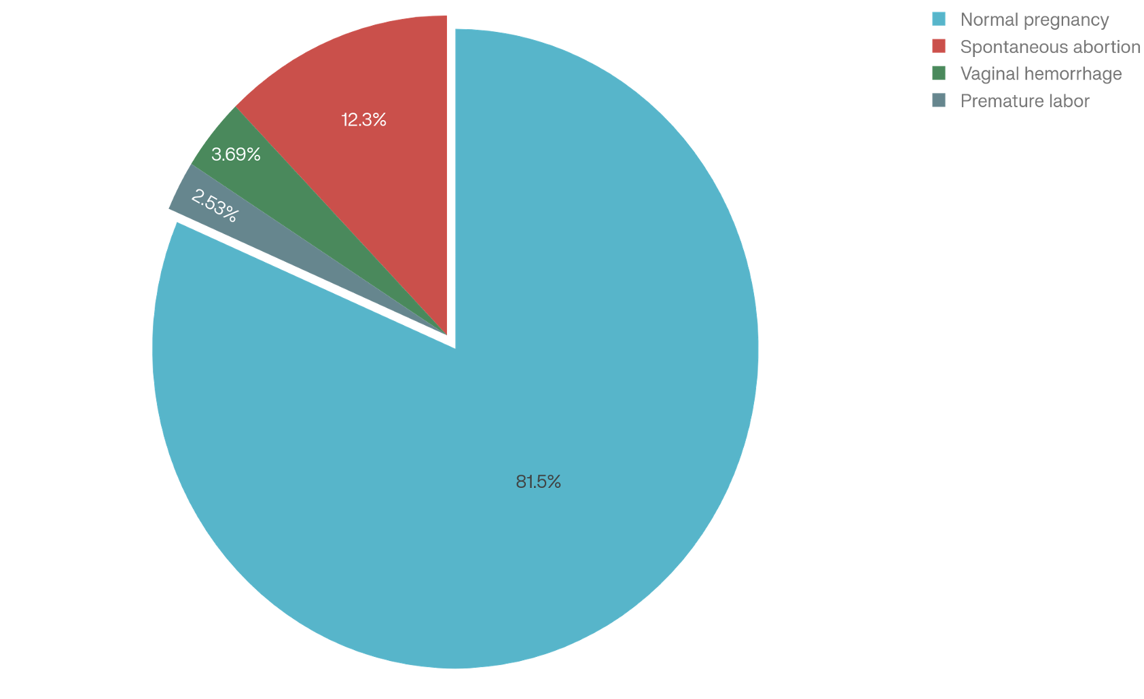
Safety Results¹⁻²
The VAERS evaluation disclosed 80.43% nonserious adverse events following immunization, with obstetric hallmarks including spontaneous abortion (3.49%) and fetal growth aberrations (0.60%). Preeminent systemic reactions and cohort findings demonstrated reactogenicity parity. Results are shown in Table 4 for VAERS while Cohort Study reactions are presented in Table 5.
Table 4. Most Prominent Adverse Events (VAERS)¹
Adverse Event | Percentage | Count
Headache | 2.21% | 482
Fatigue | 2.16% | 471
Pyrexia | 2.00% | 436
Injection Site Pain | 1.85% | 404
Dizziness | 1.42% | 309

Table 5. Cohort Study Reactions (Pregnant vs Nonpregnant)²
Symptom | Pregnant % | Nonpregnant % | P-value
Any Reaction | 18.1% | 16.9% | 0.72
Fever | 4.8% | 0.6% | 0.04*
GI Symptoms | 4.8% | 0.6% | 0.04*
Injection Pain | 12% | 11% | 0.85
*Statistically Significant
Cohort reactions remained mild (grade 1–2); inter-study consistency shows no new safety signals.
Conclusion
Integrated synthesis of the VAERS¹ pharmacovigilance dataset (n=4,869 reports) and prospective matched cohort² (n=83 pregnant vs 166 nonpregnant controls) conclusively affirms the safety of mRNA COVID-19 vaccines during pregnancy. Transient mild reactogenicity predominates without escalation of obstetric or neonatal gravitas, as evidenced by congruent adverse event profiles, background-proportional spontaneous abortion rates (3.49%), and absence of causal signals via disproportionality analyses. These reassuring findings substantially outweigh gestational SARS-CoV-2-attributable morbidity (ICU admission OR 1.9; stillbirth HR 2.1), ratifying Advisory Committee on Immunization Practices guidance for immunization irrespective of trimester. Clinical implementation should prioritize universal proffer, multilingual informed consent, and antipyretic prophylaxis to ameliorate hesitancy and equity disparities. Prospective imperatives encompass phase 4 gestation-inclusive trials, longitudinal neurodevelopmental surveillance, variant-adapted boosting assessments, and augmented global pharmacovigilance registries to sustain evidence amid viral evolution.

References
- Fraiman J, Erviti J, Jones M, et al. Safety of COVID-19 vaccines in pregnancy: a VAERS based analysis. Ther Adv Drug Saf. 2023;14:20420986231161325. doi:10.1177/20420986231161325
- Nakahara A, Biggio JR, Elmayan A, Williams FB. Safety-related outcomes of novel mRNA COVID-19 vaccines in pregnancy. Am J Perinatol. 2022;39(13):1484-1488. doi:10.1055/a-1745-1168

